**A Step-by-Step Guide to Creating a Power BI Dashboard**

### ****Create a new dashboard****

The first step to creating a new dashboard is using the Power BI service left navigation pane. You can quickly follow Microsoft Office Power BI’s guide as pictures below. Please take notice that this is an empty dashboard until you get some data or pin some tiles.

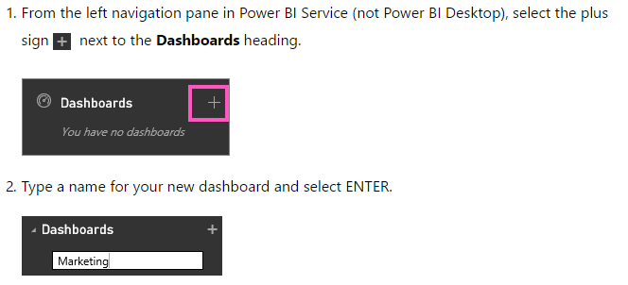

### Work with dashboards

After having a dashboard, it’s time for you to move to the next step: Adding tiles.

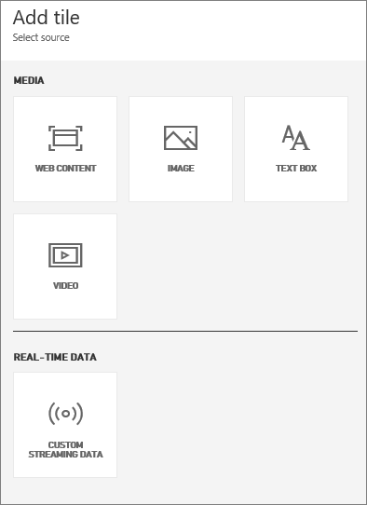

Besides creating directly, tiles can be pinned to a dashboard from Power BI Q&A, a report, another dashboard, Excel workbook on OneDrive for Business, Power BI Publisher for Excel, Quick Insights, and SRS.

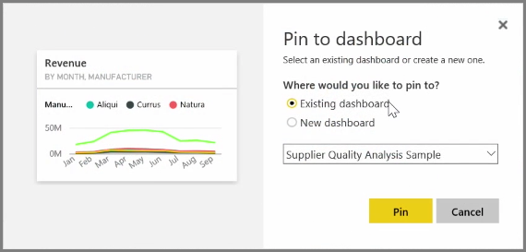

A dashboard is more than a pretty picture which is highly interactive and customizable. There are so many ways to work and interact with a dashboard, that one article is impossible to cover them all. For example, you can create more than one dashboard or control the size as well as the menu of your dashboard display. Moreover, you can manage your dashboard access right and co-author a dashboard among colleagues. Here are a few suggestions if you’re getting started:

For your later reference, here is a successful marketing sample which contains a dashboard and report from a manufacturing company named VanArsdel Ltd:

